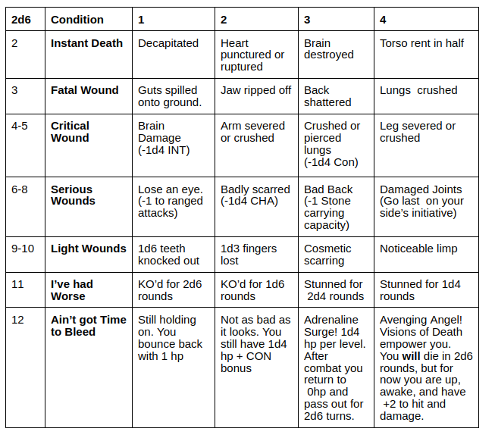
KO Check um bei Bewusstsein zu bleiben

Fatal Wound
Down. Save vs. Death -3 or KO’d.
Will die in 1d6 rounds unless Wish or Heal is applied.
Require 1d4 months of bed rest.

Critical Wounds
Save vs Death -2 or KO’d.
Will die in 2d6 rounds unless healing magic or first aid is applied (1-in-8 plus WIS mod)
Spells used for this will not restore lost hp.
Require 2d4 weeks bed rest

Serious Wounds
Save vs Death -1 or KO’d
WIll die in 3d6 rounds unless healing magic or first aid is applied (1-in-6 plus WIS mod)
Spells used for this will not restore lost hp.
Require 1d4 weeks bed rest

Light Wounds
Save vs Death or KO’d
Will die in 4d6 rounds unless healing magic or first aid is applied (no roll needed)
Requires 1d8 days bed rest

Even if they remain conscious,a character suffering from these wounds is helpless and can take no action until they recover from bedrest.

